Consulting Engineer
Suggested Specification

Controls For

Multiple Burnham Commercial Cast Iron

Hot Water Boilers

Revision
January 26, 2010

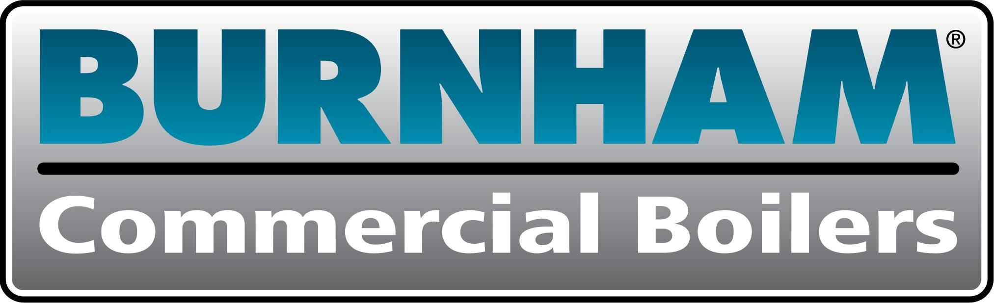 | P.O.Box 3939  Lancaster, Pennsylvania 17605-3939  Phone: 877-567-4328  www.burnhamcommercialcastiron.com
2.4 Boiler Control System
- Scope of Supply
Supply a Boiler Control System to provide safety interlocks and water temperature control. The control system shall be fully integrated into the burner control cabinet and incorporate single and multiple boiler control logic, inputs, outputs and communication interfaces. The control system shall coordinate the operation of up to eight (8) fully modulating hot water boilers and boiler pumps. The control system shall simply control boiler modulation and on/off outputs based on the boiler water supply temperature and an operator-adjusted setpoint. However, using parameter menu selections, the control system shall allow the boiler to respond to remote system water temperature and outside air temperatures with Domestic Hot Water Priority (DHWP) and Warm Weather Shut Down (WWSD) or Building Automation System (BAS) firing rate demand, remote setpoint or remote start/stop commands.

- Boiler Control
Using PID (proportional-integral-derivative) based control, the remote system water temperature shall be compared with a setpoint to establish a target boiler firing rate. If the secondary loop GPM is greater than the primary loop GPM, firing rate is increased in response to secondary loop temperature decreases. When the remote system temperature is near the boiler high limit temperature, the boiler supply sensor shall limit the maximum boiler supply temperature to prevents boiler High Limit Trips. Alternately, using parameter menu selections, the control system shall allow the boiler to respond to directly to boiler supply temperature and setpoint to establish a target boiler firing rate while remote system water temperature is used for display purposes only. Each boiler’s fuel flow control valve shall be mechanically linked to the air flow control device to assure an air rich fuel/air ratio. All the logic required to ensure that pre-purge, post-purge, light-off, and burner modulate cycles are automated shall be provided.

- Hot Water Temperature Setpoint
When the controller is in the local control mode, the control system shall establish the setpoint based on outside air temperature and a reset function curve or be manually adjusted by the operator. When enabled, the setpoint shall be adjusted above a preset minimum setpoint upon sensing a domestic hot water demand contact input. When in remote mode, the control system shall accept a Modbus or 4-20mAdc remote setpoint or firing rate demand signal from an external Building Automation System (BAS).

- Multiple Boiler Sequence
Multiple boilers shall be modulated in “Unison” (all at the same firing rate). The control system shall utilize both water temperature and boiler firing rate percent to start and stop the boilers and shall minimize the total number of boilers in operation. The control system shall start and stop boilers when the water temperature is outside the adjustable temperature limit for longer than the adjustable time delay. In order to minimize temperature deviations, the control system shall start and stop the next boiler when the “lead” boiler is at an adjustable firing rate limit for longer than the adjustable time delay. The control system shall monitor both boiler lockout and limit circuits to automatically skip over those boilers that are powered down for maintenance, tripped or otherwise will not start. When rotation is enabled the lead boiler shall automatically rotate every 1 to 168 hours. The boiler shall be run at low fire for warm-up for a preset low fire hold time. When enabled, warm weather shut down control logic shall prevent boiler operation.

- User Interface
A panel front-mounted English language, two line, sixteen character LCD message display shall be provided to display numeric data, startup and shutdown sequence status, alarm, system diagnostic, first-out messages and boiler historical information. Historical information shall include the last ten lockout and alarm conditions, number of boiler cycles, boiler hours and last ten low boiler inlet temperature events. When boiler inlet water temperature is below a minimum setpoint a low temperature events shall be stored with time, date, “lowest temperature for event” and “duration below setpoint” data. A panel mounted red alarm light shall annunciate alarm messages. Alarm conditions requiring a manual reset shall be annunciated by a flashing red light. At a minimum, the boiler system shall display the following:

  - Numeric Display with Engineering Units:
    - Boiler supply Water Temperature
    - Boiler Return Water Temperature
    - Remote System Temperature (when required by contract drawings)
    - Outside Air Temperature (when required by contract drawings)
    - Firing Rate %
    - Boiler Temperature Setpoint
    - Mixing Valve % (when required by contract drawings)

  - Status, Startup And Shutdown Sequence English language Messages:
    - Boiler disabled
    - Warm Weather Shutdown
    - Lockout
    - Pump Purge
    - Limit Hold
    - Purge / Pilot Ignition
    - Low Fire / Pilot Ignition
    - Main Burner Ignition
    - Boiler Running
    - Fan Post Purge
    - Pump Cooldown
    - Standby

  - Alarm, System Diagnostic, First-Out English language Messages: (numeric code numbers shall not be acceptable):
    - Low Water Level (when required by contract drawings)
    - Low Water Flow (when required by contract drawings)
    - Fuel Limit (gas pressure or oil temperature)
    - High Boiler supply Temperature Limit
    - Low Return Water Temperature
    - Low Air Flow
    - Flame Safeguard Internal Fault
    - High supply Temperature
    - Supply Temperature Sensor Fault
    - Return Temperature Sensor Fault
    - Outside Air Temperature Sensor Fault
    - Remote System Temperature Sensor Fault
    - Remote Input Signal Fault
    - Modbus Communication Fault
    - Memory Fault

- Flame Safeguard (FSG)
An industrial duty microprocessor-based FSG shall provide: safety interlocks, flame monitoring protection and timed sequences. Sequences shall include forced draft fan start and stop, furnace purge, burner light-off and shutdown and post-purge. Control components shall be fully integrated for automatic sequencing of light-off and shutdown.

- Boiler Pump Sequence
Include primary water pump control to allow boiler warm-up to the return water temperature before the boiler start; continue water flow for an adjustable cool down period after the boiler has stopped; and ensure water is always moving past the remote system temperature sensor even after the last boiler has been stopped. The pump shall immediately stop if any trips occur during pre-purge, pilot, or main flame trial for ignition.

- Flue Gas Condensate Protection
Include alarms and control logic to help prevent corrosion in the boiler due to sustained flue gas condensation. These features become increasingly important as we add energy savings modulation and outdoor air reset functions. Provide a 4-20mAdc, 3 way mixing valve control output based on PID control, measured boiler inlet temperature and minimum inlet temperature setpoint and measured boiler inlet and outlet temperature difference and differential setpoint. If the boiler inlet water temperature drops below setpoint or the differential temperature is excessive the valve shall open to allow hot boiler outlet water to blend with cold inlet water temperature. The valve repositions toward 0% recirculation after inlet water temperature increases above setpoint. Low boiler inlet water temperature shall be alarmed using an alarm message, indicating light and an alarm contact output. Excessively low boiler inlet temperature events shall be stored with boiler historical data.

- Mixing Valve (when required by contract drawings)
In order to prevent low inlet water temperature, provide an electric actuated three-way mixing valve with a 4-20 mAdc input control signal and slow (1 minute) travel time for each boiler. If the boiler inlet water temperature is below 130 ° F (adjustable) or when boiler differential temperature is above 40° F (adjustable), the valve shall slowly jog closed causing boiler outlet water to blend with the inlet water. When the inlet water temperature and differential temperature return to an acceptable range, the boiler outlet valve shall slowly jog open.

- Communication
Include an RS485 Modbus slave or peer-to-peer communications data highway on each boiler control system. When peer-to-peer communication is enabled the data highway shall allow the connected boilers to exchange signals as required to provide coordinated fully modulating lead/lag functions. It shall not be required to wire individual control signals between boilers. When Modbus communication is enabled the data highway shall allow individual boiler limits, lockout, boiler and system temperatures and firing rate status to be readable and water setpoint, boiler firing rate, and start/stop command to be readable and writable. Provide all equipment capabilities specified in this paragraph, even if a connecting SCADA (Supervisory Control And Data Acquisition system, typically a desk top personal computer) system or Building Automation System (BAS) is not included in this project.

- Quality Assurance
The boiler control system shall be supplied as part of a factory assembled, tested burner control cabinet.

